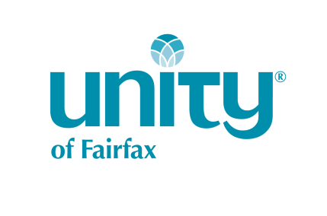
Direct Deposit Authorization Form

Your Information
Please print clearly in block-style text.

Your Name |  | Email Address Please add me to the Unity email list.
Street Address New address |  | City State Zip
Effective (date)________________________, I commit $_______________ monthly to Unity of Fairfax through either an automatic charge to my credit/debit card or Electronic Funds Transfer (EFT). If I choose EFT authorization, I am including a voided check to enable processing. I understand that this authorization will remain in full force and effect on an on-going recurring basis until I provide written instructions to change or cancel this arrangement, either mailed to Unity of Fairfax, 2854 Hunter Mill Road, Oakton, VA 22124, or emailed to accountant@unityoffairfax.org.
EFTs are processed on the 10^{th.} CREDIT CARDs on the 15th each month. Check this box to confirm.
EFT: |  |  |  |  |  | Credit/Debit Card:
 | Bank Name
Monthly Amount for Transfer (Recurring) |  |  |  |  |  | Monthly Amount for Transfer (Recurring)  AMEX MC VISA DISCOVER
Bank Account Number Checking Savings
ABA Routing Number |  |  |  |  |  | Card # Exp. Date
 | Printed name as it appears on your financial instrument
 |  |  | Signature Date
Long Term Giving Plans
The Mildred Park Society seeks to recognize those who have named Unity of Fairfax in their estate planning. If you are interested in learning more, please contact accountant@unityoffairfax.org.
I have included Unity of Fairfax in my estate planning.
Directions for Submitting Your Direct Deposit Commitment
Your privacy is very important to us. We suggest submitting your Direct Deposit Form in one of the following ways to ensure confidentiality:
- Place your completed form in a sealed envelope and hand deliver to Patie Wilcox, Finance & Operations Director.
- Place your completed form in a sealed envelope and deposit in the locked box provided for these forms in the Atrium.
- Mail to the church office: Unity of Fairfax, ATTN: Patie Wilcox, 2854 Hunter Mill Road, Oakton, VA 22124.
Thank you for your heart-felt investment in Unity of Fairfax.

